Annex III
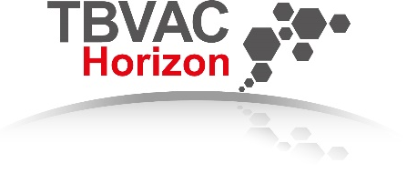
TBVAC-Horizon application form
Call name: Call for applications to assess efficacy of Mycobacterium tuberculosis vaccine candidates in a mouse model; Call 1 (of 3)
Call open: 16 October 2023
Application deadline: 31 December 2023

Applicant information
Organization name
Applicant/contact person name
Email address
Phone number
Vaccine candidate
Vaccine components (including adjuvant/delivery system if applicable) and dosage (concentration and volume per dose)
Preferred route of administration and immunisation schedule
Summary of the concept vaccine (incl. adjuvant/delivery system if applicable)
Please add references where relevant in case part of the work has been published; max 4 pages
Address the go/no go criteria as well as layer 1 priority setting criteria described in Annex II in detail.
Shortly address the Layer 2 criteria if known (optional).

If selected, we will be timely providing all information and materials needed to enable the experiment itself as well as preparatory activities, including biosafety approval.
Place, Date |  | Applicant name and signature

To apply, please send this completed form to info@tbvi.eu before 1 January 2024.

