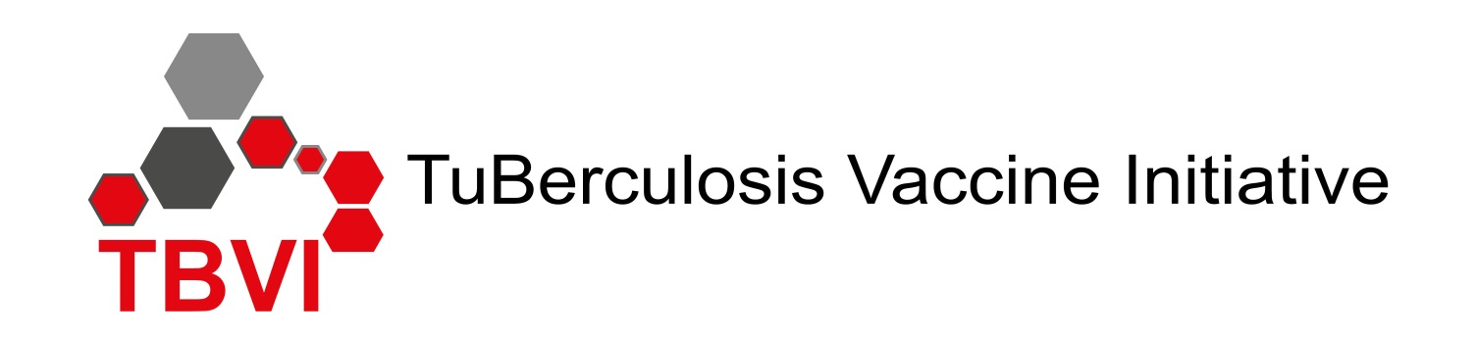

Symposium programme:

“TB Vaccines: Global Collaboration and
Recent Advances in the Field”
Tuesday afternoon 29th January 2019

Programme

13.50 – 14.00 Photo whole group outside in front of the Maison des Congres

14.00 - 14.05 Opening and Welcome - Nick Drager, TBVI, the Netherlands

Global collaboration
14.05-14.25 TBVAC2020: advances in the TB vaccine field - Ann Rawkins, PHE_United Kingdom
14.25-14.45 BMGF TB vaccine programme – strategic directions and current activities – Willem Hanekom, (by Anne Kasmar), BMGF, United States
14.45-15.05 Gates MRI Strategic Direction and Current TB Vaccine Activities - Penny Heaton GMRI, United States
15.05-15.25 NIAID strategic plan for TB research and current activities related to TB vaccines
Katrin Eichelberg, NIH, United States
15.25-15.40 Towards Horizon Europe – Hannu Laang, EC, Belgium
15.40-16.00 A new strategy for the Global HIV Vaccine Enterprise – facilitating solutions to complex challenges in HIV vaccine development and roll out, Birgit Poniatowski, International AIDS Society, Switzerland
16.00-16.15 Future perspectives for TB vaccine development - Ole Olesen, EDCTP, The Netherlands
16.15-16.35 Introducing VALIDATE: A Global Challenges Research Fund network in vaccine R&D for complex intracellular pathogens, Helen McShane, UOXF, United Kingdom

16.35-17.00 Coffee/Tea – Maison des Congres

TB treatment and vaccines
17.00-17.20 Preferred product characteristics for a therapeutic TB vaccine – Barry Walker, TBVI, the Netherlands
17.20-17.35 New TB drug regimes and prospects for therapeutic vaccines and adjunct host- directed therapy, Frank Cobelens, AIGHD, the Netherlands

The TB vaccine pipeline
17.35-17.50 Preferred Product Characteristics for a new TB vaccine –Johan Vekemans, WHO, Switzerland
17.50-18.10 TB vaccine pipeline and Pathway to TB vaccines – Georges Thiry, TBVI, the Netherlands
18.10 -18.30 Efficacy trials of M72/AS01E and H4/BCG revaccination - Key takeaways –
Ann Ginsberg- IAVI, United States

19.00 – 20.00 Reception (Eurotel)

20.00 Dinner - Restaurant Eurotel

