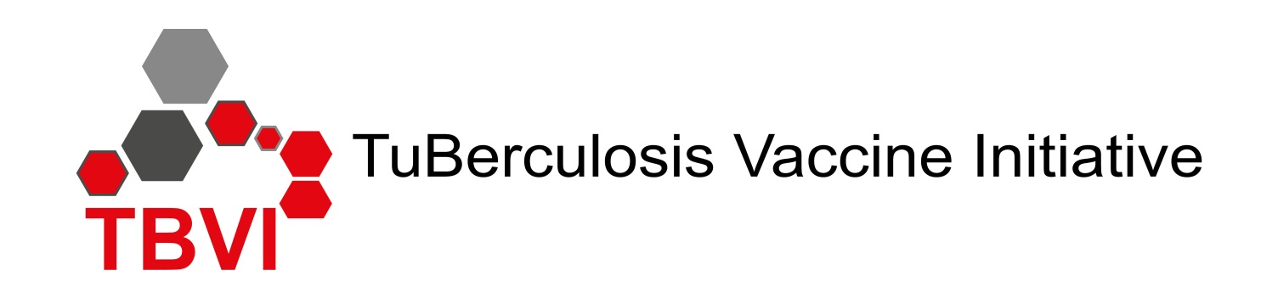

Draft Symposium programme:

“TB Vaccines: Global Collaboration and
Recent Advances in the Field”
Tuesday afternoon 29th January 2019

Programme

14.00 - 14.05 Opening and Welcome - Nick Drager, TBVI, the Netherlands

Global collaboration
14.05-14.25 Penny Heaton GMRI, United States
14.25-14.45 Katrin Eichelberg (tbc), NIH, United States
14.45-15.05 speaker tbc, IAS Global HIV Vaccine Enterprise, country??
15.05-15.25 Ole Olesen, EDCTP, The Netherlands
15.25-15.45 Towards Horizon Europe (title tbc)– Hannu Laang (tbc), EC, Belgium
15.45-16.00 BMGF TB vaccine programme – strategic directions and current activities – Willem Hanekom, BMGF, United States
16.00-16.20 TBVAC2020: advances in the TB vaccine field - Ann Rawkins, PHE_United Kingdom

16.20-16.45 Coffee/Tea – Maison des Congres

TB treatment and vaccines
16.45-17.05 New TB drug regimens and prospects for adjunct host-directed therapy – Willo Brock tbc), TB alliance, United States
17.05-17.20 Target Product Profile for a therapeutic TB vaccine – Barry Walker, TBVI, the Netherlands

The TB vaccine pipeline
17.20-17.35 Preferred Product Characteristics for a new TB vaccine –Johan Vekemans, WHO, Switzerland
17.35-17.55 Vaccine pipeline and target specific stage gating criteria for TB vaccines – Georges Thiry, TBVI, the Netherlands
17.55 -18.15 (Clinical trials of) BCG revaccination and M72 - Ann Ginsberg- AERAS

19.00 – 20.00 Reception (Eurotel)

20.00 Dinner - Restaurant Eurotel

