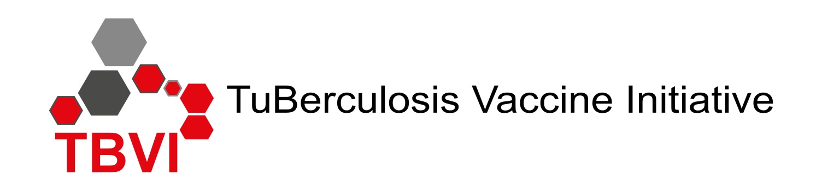

Symposium programme:

“Therapeutic vaccination and host-directed (immuno) therapy against TB”

Tuesday afternoon 30th January 2018

Programme

14.00 - 14.05 Opening and Welcome - Nick Drager, TBVI, the Netherlands. Presentation Nick Drager

Chair: Frank Verreck (BPRC, the Netherlands)
14.05 – 14.30 Introductory and overarching overview - Stefan Kaufmann, MPIIB, Germany
Presentation Stefan Kaufmann

14.30 – 15.00 Exploring host-pathogen interactions for host directed therapies - Dr. Ulrich Schaible, Research Centre Borstel, Borstel, Germany Presentation Ulrich Schaible.

15.00 – 15.30 Evaluation of host-directed therapies against TB in the macaque model - Dr. Deepak Kaushal, Tulane NHP Research Centre (TNPRC), Covington, United States

15.30 – 16.00 A perspective on therapeutic vaccination from the TB drug development space -
Prof. Eric Nuermberger, Johns Hopkins University, Baltimore, United States

16.00 – 16.30 Coffee break / snack

16.30 – 17.00 Strategies for clinical development of therapeutic vaccines for DR-TB - Prof. Dr. Mark Hatherill, South African Tuberculosis Initiative, University of Cape Town, South Africa Presentation Mark Hatherill

17.00 – 17.30 Therapeutic vaccines in HIV infection: challenges and future - Prof. Dr. Giuseppe Pantaleo, Swiss Vaccine Research Institute, CHUV, Lausanne, Switzerland

17.30 – 18.00 Developing biomarkers into products: An overview - Bill Rodriguez, Draper Richards Kaplan Foundation, Boston, United States. Presentation Bill Rodriguez

18.00 – 19.00 Final session: EDCTP-supported new TB vaccine clinical projects
Chair: Ole Olesen – EDCTP, the Netherlands. Presentatie Ole Olesen

18.00 - 18.05 Introduction – Hannu Laang, EC, Belgium Presentatie Hannu Laang

18.05 – 18.20 A multicenter phase III clinical trial with VPM1002 - Leander Grode, VPM, Germany

18.20 – 18.35 MTBVAC in newborns, a phase 2a clinical trial - Ingrid Murillo, Biofabri, Spain
Presentatie Ingrid Murillo

18.35 – 18.50 Prevention of recurrent TB disease consortium, a phase 2a trial (H56:IC31) - Morten Ruhwald, SSI), Denmark

18.50 - 19.05 A clinical trial to demonstrate the safety and efficacy of H56:IC31 for the prevention of tuberculosis infection - Ann Ginsberg, Aeras, United States Presentatie Ann Ginsberg

19.15 – 20.00 Reception (Eurotel)

20.00 Dinner - Restaurant Eurotel

