MASTERCLASS VACTRAIN LEIDEN
May 9-10, 2016

Venue: | Golden Tulip Hotel  Schipholweg 3  Leiden  phone: +31 71 4083500  http://www.goldentulipleidencentre.nl/en/location

date |  | time | location
Monday May 9
Masterclass VACTRAIN |  | 09.00 – 18.00 | Meeting room Golden Tulip hotel Leiden
Lunch |  | 12.30 – 13.30 | Restaurant Golden Tulip Hotel
Dinner |  | 19.00 | Restaurant Bree33,  Breestraat 33, Leiden
Tuesday May 10
Masterclass VACTRAIN |  | 09.00 – 16.00 | Meeting room Golden Tulip hotel Leiden
Lunch |  | 12.30 – 13.30 | Restaurant Golden Tulip Hotel
Dinner |  | 18.30 | Restaurant The Bishop  Middelweg 7-9, Leiden

Contact person : | Wendy van Hemmen
e-mail : | w.vanhemmen@lumc.nl

ACCOMMODATION:
We have special agreements with:

IBIS Hotel Leiden
Stationsplein 240-242
2312 AR Leiden
Tel : +31 71 516 00 00
Email : h8087-re@accor.com
Website : http://www.ibis.com/gb/hotel-8087-ibis-leiden-centre/index.shtml

Price:
€ 85,50 (with breakfast) *
*Incl. city and local taxes : € 2.50 (per night/ per person) ; single use

Special booking code: LUMC080516
This code can only be used for bookings by e-mail : h8087-re@accor.com
Please book before April 19 : after this date you can still book for the same price, but subject to availability.

FITLAND/Level Hotel Leiden
Bargelaan 180
2333 CW Leiden
Tel : + 31 71 87 00 260
Email : hotelleiden@fitland.nl
Website : http://www.hampshire-hotels.com/en/hampshire-hotel-fitland-leiden

Price:
€ 79,00 (with breakfast) *
*Incl. city and local taxes : € 2.50 (per night/ per person) ; single use

Special booking code: GF6175
Please use enclosed booking form.
Please book before April 19 : after this date you can still book for the same price, but subject to availability.

Plan

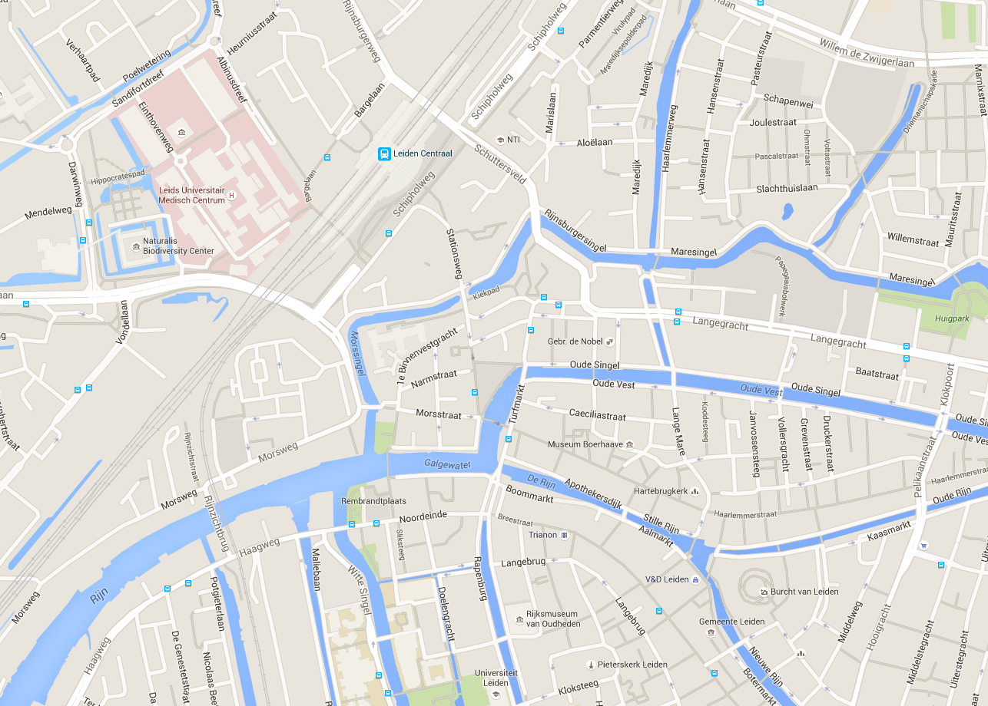
The Bishop
BREE33
Leiden
Central Station
Hotel Fitland
Hotel Golden Tulip
Hotel IBIS
LUMC

Travelling

By air:
Airport: Amsterdam Schiphol
http://www.schiphol.nl/Travellers/ToFromSchiphol/PublicTransport.htm

By Public Transport
Train:
Every 11-12 minutes a train leaves for Leiden Central Station. Journey takes 17 minutes.
Book train tickets at:
http://www.ns.nl/en/travellers/arrange-and-buy/tickets-and-passes/purchasing-tickets

By Car:

Coming from Rotterdam (A13, A4):
Take the A13 and then the A4 towards Amsterdam; exit at junction 6a (Zoeterwoude-Rijndijk, Leiden-Oost) and turn left. At the end of the road, turn right and follow the signposting ('H-Ziekenhuizen').

Coming from Utrecht (A12, N11):
Take the A12 and at Bodegraven take the exit for Leiden (N11). At the end of the N11, turn right and follow the signposting ('H-Ziekenhuizen').

Coming from The Hague (N44, A44):
From The Hague, take the N44 (which turns into the A44) and exit it at junction 8 (Leiden, Noordwijk, Katwijk); turn right and follow the signposting ('H-Ziekenhuizen').

Coming from Amsterdam (A4, A44):
Take the A4 and then the A44 in the direction of Leiden-West. Exit the A44 at junction 8 (Leiden, Noordwijk, Katwijk, N206), turn left and go under the viaduct. Follow the signposting ('H-Ziekenhuizen').

Car Park
LUMC has own car-park / guests VACTRAIN meeting will get a card for free parking.

